2024

Admin

[Company name]

1/1/2024



ENGINEERS

ENGINEER

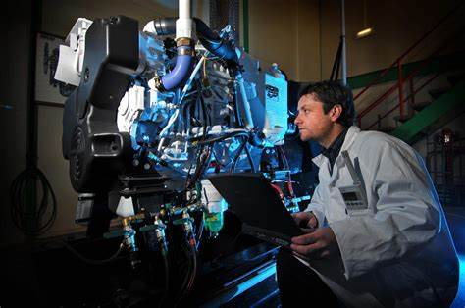Engineers, as practitioners of engineering, are professionals who invent, design, analyze, build and test machines, complex systems, structures, gadgets and materials to fulfill functional objectives and requirements while considering the limitations imposed by practicality, regulation, safety and cost.[1][2] The word engineer (Latin ingeniator,[3] the origin of the Ir. in the title of engineer in countries like Belgium and The Netherlands) is derived from the Latin words ingeniare ("to contrive, devise") and ingenium ("cleverness").[4][5] The foundational qualifications of a licensed professional engineer typically include a four-year bachelor's degree in an engineering discipline, or in some jurisdictions, a master's degree in an engineering discipline plus four to six years of peer-reviewed professional practice (culminating in a project report or thesis) and passage of engineering board examinations.

TYPES OF ENGINEERS

**1.Aerospace Engineer 2. Chemical Engineering**

**3.Civil Engineering 4.Electrical Engineer**

**5.Mechanical Engineering 6.Computer Engineering**

**7.Environmental Engineering 8.Biomedical Engineer**

**9.Petroleum Engineer 10.Industrial Engineering**

**11.Materials Engineer 12.Structural Engineering**

**13.Automobile Engineering 14.Nuclear Engineer**

**15.Software Engineer**

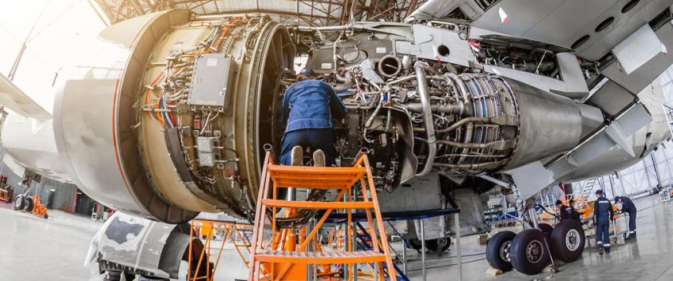1.**Aerospace Engineer** is the primary field of engineering concerned with the development of aircraft and spacecraft. It has two major and overlapping branches: aeronautical engineering and astronautical engineering. Avionics engineering is similar, but deals with the electronics side of aerospace engineering.

"Aeronautical engineering" was the original term for the field. As flight technology advanced to include vehicles operating in outer space, the broader term "aerospace engineering" has come into use.[4] Aerospace engineering, particularly the astronautics branch, is often colloquially referred to as "rocket science".

**Overview**

Flight vehicles are subjected to demanding conditions such as those caused by changes in atmospheric pressure and temperature, with structural loads applied upon vehicle components. Consequently, they are usually the products of various technological and engineering disciplines including aerodynamics, Air propulsion, avionics, materials science, structural analysis and manufacturing. The interaction between these technologies is known as aerospace engineering. Because of the complexity and number of disciplines involved, aerospace engineering is carried out by teams of engineers, each having their own specialized area of expertise.

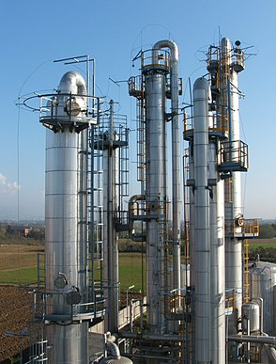2. **Chemical Engineering** A chemical engineer is a professional equipped with the knowledge of chemistry and other basic sciences who works principally in the chemical industry to convert basic raw materials into a variety of products and deals with the design and operation of plants and equipment.[1] This person applies the principles of chemical engineering in any of its various practical applications, such as

Design, manufacture, and operation of plants and machinery in industrial chemical and related processes ("chemical process engineers");

Development of new or adapted substances for products ranging from foods and beverages to cosmetics to cleaners to pharmaceutical ingredients, among many other products ("chemical product engineers");

Development of new technologies such as fuel cells, hydrogen power and nanotechnology, as well as working in fields wholly or partially derived from chemical engineering such as materials science, polymer engineering, and biomedical engineering. This can include working of geophysical projects such as rivers, stones, and signs.

**Overview**

Chemical engineers use computers to manage automated systems in production plants.

Historically, the chemical engineer has been primarily concerned with process engineering, which can generally be divided into two complementary areas: chemical reaction engineering and separation processes. The modern discipline of chemical engineering, however, encompasses much more than just process engineering. Chemical engineers are now engaged in the development and production of a diverse range of products, as well as in commodity and specialty chemicals. These products include high-performance materials needed for aerospace, automotive, biomedical, electronic, environmental and military applications. Examples include ultra-strong fibers, fabrics, adhesives and composites for vehicles, bio-compatible materials for implants and prosthetics, gels for medical applications, pharmaceuticals, and films with special dielectric, optical or spectroscopic properties for opto-electronic devices. Additionally, chemical engineering is often intertwined with biology and biomedical engineering. Many chemical engineers work on biological projects such as understanding biopolymers (proteins) and mapping the human genome.

**3.Civil Engineering**  is a professional engineering discipline that deals with the design, construction, and maintenance of the physical and naturally built environment, including public works such as roads, bridges, canals, dams, airports, sewage systems, pipelines, structural components of buildings, and railways.[1][2]

Civil engineering is traditionally broken into a number of sub-disciplines. It is considered the second-oldest engineering discipline after military engineering,[3] and it is defined to distinguish non-military engineering from military engineering.[4] Civil engineering can take place in the public sector from municipal public works departments through to federal government agencies, and in the private sector from locally based firms to global Fortune 500 companies.

**Sub-Disciplines**

The Akashi Kaikyō Bridge in Japan, currently the world's second-longest suspension span.

There are a number of sub-disciplines within the broad field of civil engineering. General civil engineers work closely with surveyors and specialized civil engineers to design grading, drainage, pavement, water supply, sewer service, dams, electric and communications supply. General civil engineering is also referred to as site engineering, a branch of civil engineering that primarily focuses on converting a tract of land from one usage to another. Site engineers spend time visiting project sites, meeting with stakeholders, and preparing construction plans. Civil engineers apply the principles of geotechnical engineering, structural engineering, environmental engineering, transportation engineering and construction engineering to residential, commercial, industrial and public works projects of all sizes and levels of construction.

4**.Electrical Engineer** is an engineering discipline concerned with the study, design, and application of equipment, devices, and systems which use electricity, electronics, and electromagnetism. It emerged as an identifiable occupation in the latter half of the 19th century after the commercialization of the electric telegraph, the telephone, and electrical power generation, distribution, and use.

Electrical engineering is divided into a wide range of different fields, including computer engineering, systems engineering, power engineering, telecommunications, radio-frequency engineering, signal processing, instrumentation, photovoltaic cells, electronics, and optics and photonics. Many of these disciplines overlap with other engineering branches, spanning a huge number of specializations including hardware engineering, power electronics, electromagnetics and waves, microwave engineering, nanotechnology, electrochemistry, renewable energies, mechatronics/control, and electrical materials science.[a]

Electrical engineers typically hold a degree in electrical engineering, electronic or electrical and electronic engineering. Practicing engineers may have professional certification and be members of a professional body or an international standards organization. These include the International Electrotechnical Commission (IEC), the Institute of Electrical and Electronics Engineers (IEEE) and the Institution of Engineering and Technology (IET, formerly the IEE).

Electrical engineers work in a very wide range of industries and the skills required are likewise variable. These range from circuit theory to the management skills of a project manager. The tools and equipment that an individual engineer may need are similarly variable, ranging from a simple voltmeter to sophisticated design and manufacturing software.

**Work of electrical engineer**

An electrical engineer specializes in the design, development, and maintenance of electrical systems and devices. These professionals apply principles of electrical engineering to create solutions that address a wide range of needs, from powering homes and businesses to designing advanced electronics and communication systems.

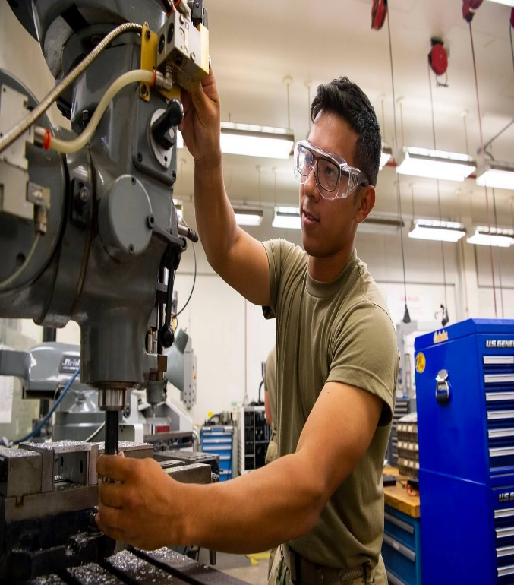**5.Mechanical Engineering** is the study of physical machines that may involve force and movement. It is an engineering branch that combines engineering physics and mathematics principles with materials science, to design, analyze, manufacture, and maintain mechanical systems.[1] It is one of the oldest and broadest of the engineering branches.

Mechanical engineering requires an understanding of core areas including mechanics, dynamics, thermodynamics, materials science, design, structural analysis, and electricity. In addition to these core principles, mechanical engineers use tools such as computer-aided design (CAD), computer-aided manufacturing (CAM), computer-aided engineering (CAE), and product lifecycle management to design and analyze manufacturing plants, industrial equipment and machinery, heating and cooling systems, transport systems, motor vehicles, aircraft, watercraft, robotics, medical devices, weapons, and others.[2][3]

Mechanical engineering emerged as a field during the Industrial Revolution in Europe in the 18th century; however, its development can be traced back several thousand years around the world. In the 19th century, developments in physics led to the development of mechanical engineering science. The field has continually evolved to incorporate advancements; today mechanical engineers are pursuing developments in such areas as composites, mechatronics, and nanotechnology. It also overlaps with aerospace engineering, metallurgical engineering, civil engineering, structural engineering, electrical engineering, manufacturing engineering, chemical engineering, industrial engineering, and other engineering disciplines to varying amounts. Mechanical engineers may also work in the field of biomedical engineering, specifically with biomechanics, transport phenomena, biomechatronics, bionanotechnology, and modelling of biological systems.

**Work of mechanical engineering Mechanical** engineering is a branch of engineering that combines engineering physics and mathematics principles with materials science, to design, analyze, manufacture, and maintain mechanical systems1. Mechanical engineers design machines and other solutions to solve mechanical problems and challenges2. They apply their knowledge of mechanics, thermodynamics, structural analysis, and electricity to design and develop parts, tools, and systems3. While working as a mechanical engineer, you will likely participate in the following job functions45:

Analyze problems to determine how mechanical and thermal devices might help solve those particular problems.

Design and redesign mechanical and thermal devices using computer-aided tools.

Create physical prototypes and virtual simulations before proceeding to product creation.

Oversee the manufacturing process for devises from both the office and work site.

Investigate equipment failures.

**6.Nuclear engineer** is the engineering discipline concerned with designing and applying systems that utilize the energy released by nuclear processes.[1][2] The most prominent application of nuclear engineering is the generation of electricity. Worldwide, some 440 nuclear reactors in 32 countries generate 10 percent of the world's energy through nuclear fission.[3] In the future, it is expected that nuclear fusion will add another nuclear means of generating energy.[4] Both reactions make use of the nuclear binding energy released when atomic nucleons are either separated (fission) or brought together (fusion). The energy available is given by the binding energy curve, and the amount generated is much greater than that generated through chemical reactions. Fission of 1 gram of uranium yields as much energy as burning 3 tons of coal or 600 gallons of fuel oil,[5] without adding carbon dioxide to the atmosphere.[6]

**Work of nuclear engineer** A Nuclear Engineering career involves analysing energy transmission, conversion, and storage systems and also solving operational problems with the reactor cores and shielding, hydraulic and electrical systems, and complex instrumentation such as monitoring equipment.

**7.Software engineer** is an engineering approach to software development.[1][2][3] A practitioner, a software engineer, applies the engineering design process to develop software.

The terms programmer and coder overlap software engineer, but they imply only the construction aspect of typical software engineer workload.[4]

A software engineer applies a software development process,[1][5] which involves the definition, implementation, testing, management and maintenance of software systems and with development of the software development process itself.

**Work of software engineer** Designing and creating software solutions and applications.

Solving complex problems and developing innovative solutions that help businesses and organizations achieve their goals.

Working in a team of developers in several projects.

Developing well-optimized and efficient source code for the latest software applications.

Producing software tools and amalgamating them to a fully functional software system.

Maintaining and testing software to ensure that it is working properly.

**8.Computer Engineering** is a branch of computer science and electronic engineering that integrates several fields of computer science and electronic engineering required to develop computer hardware and software.[1] Computer engineering is referred to as computer science and engineering at some universities.

Computer engineers require training in electronic engineering, computer science, hardware-software integration, software design, and software engineering. It uses the techniques and principles of electrical engineering and computer science, and can encompass areas such as artificial intelligence (AI), robotics, computer networks, computer architecture and operating systems. Computer engineers are involved in many hardware and software aspects of computing, from the design of individual microcontrollers, microprocessors, personal computers, and supercomputers, to circuit design. This field of engineering not only focuses on how computer systems themselves work, but also on how to integrate them into the larger picture.[2] Robotics are one of the applications of computer engineering.

Computer engineering usually deals with areas including writing software and firmware for embedded microcontrollers, designing VLSI chips, analog sensors, mixed signal circuit boards, and operating systems. Computer engineers are also suited for robotics research, which relies heavily on using digital systems to control and monitor electrical systems like motors, communications, and sensors.

In many institutions of higher learning, computer engineering students are allowed to choose areas of in-depth study in their junior and senior years because the full breadth of knowledge used in the design and application of computers is beyond the scope of an undergraduate degree. Other institutions may require engineering students to complete one or two years of general engineering before declaring computer engineering as their primary focus.

**Work of computer engineer** Computer engineers design, build, and test hardware components and systems. A computer engineer works with software developers to ensure the hardware and software work in tandem while balancing factors such as performance and material cost**.**